CARA HARDENING LAMP UBUNTU
Pertama kita install terlebih dahulu:
apt-add-repository ppa:ondrej/php
apt-add-repository ppa:ondrej/apache2
apt update && apt upgrade -y
apt install gnupg2 software-properties-common curl wget git unzip -y
apt install auditd -y
apt install fail2ban -y
apt install certbot python3-certbot-apache -y
apt install apache2 php php-xmlrpc php-mysql php-gd php-curl php-cli php-mysql php-mbstring php-xdebug libapache2-mod-php libapache2-mod-evasive libapache2-mod-security2 modsecurity-crs -y
apt install mysql-server mysql-client -y

Setelah install kita configurasi:

1.CONFIG LINUX SSH
ufw allow openssh
ufw allow 80/tcp
ufw allow 443/tcp
ufw enable

nano /etc/ssh/sshd_config > Ubah PermitRootLogin no dan PasswordAuthentication no
systemctl restart ssh

2.CONFIG APACHE
systemctl enable apache2
systemctl start apache2
a2enmod security2
a2enmod evasive
nano /etc/apache2/conf-enable/security.conf > ubah menjadi ServerTokens dari On ke Prod
nano /etc/apache2/mod-available/evasive.conf >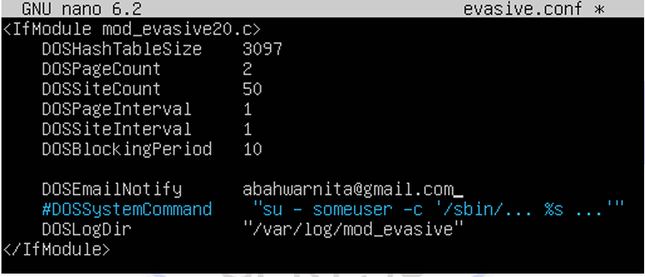
nano /etc/apache2/sites-available/000-default.conf
cd /etc/modsecurity > mv modsecurity.conf-recommended modsecurity.conf
nano modsecurity.conf
systemctl restart apache2

3.CONFIG MYSQL
mysql_secure_installation > y semua dan jika ada pilihan password low,medium disarankan low
mysql -u root -p
delete from mysql.user where User=’root’ and Host!=’localhots’;
flush privileges;
create user ‘appuser’@’localhost’ identified by ‘PasswordKuat’;
grant select,insert,update,delete on namadb.* to ‘appuser’@’localhost’;
flush privileges;
4.CONFIG PHP
nano /etc/php/8.4/apache2/php.ini > cari dan isi
session.cookie_httponly = 1
session.cookie_secure = 1
session.use_strict_mode = 1
systemctl restart apache2

